## Table of Contents

Executive Summary 1

Table of Contents 2

Intro 3

Mission Statement 4

Latest Project Plan 4

Updated PDS Summary 5

Top Level External Search 7

Top Level Internal Search 7

Final Design Evaluation and Selection 8

Progress on Detailed Design 11

Conclusion and Recommendations 12

References 14

Appendix A 15

Appendix B 18

Matlab Script for Plane 18

## 

## Intro

Oregon Small Satellite Project is an association composed by a group of higher education institutions and local industry experts. The capstone team is managed and sponsored by OreSat and PSAS (Portland State Aerospace Society). OreSat’s primary goal is to launch Oregon’s first satellite. As such, this capstone is to conduct a thermal analysis on the OreSat and provide the OreSat design team with actionable suggestions.

OreSat is a 2U CubeSat, which is a miniaturised (U-class) satellite originally developed in 1999 at California Polytechnic State University for low Earth orbit data collection. The original CubeSat had dimensions of 10x10x10 cubic cm and a mass of 1.33kg. CubeSats are generally made with commercial off-the-shelf components and cost a mere $50,000 per project—a fraction of the cost of large satellites.

OreSat is an open source project and is backed by NASA’s CubeSat Launch Initiative (CSLI). PSAS has an agreement with the CSLI for a flight to and launch from the International Space Station (ISS). In exchange OreSat’s mission is to observe cirrus clouds in the upper atmosphere of earth. PSAS has an internal goal to use the satellite as a STEM outreach tool for grade, middle and high school students in Oregon.

Understanding the thermal behaviour of the satellite and its environment is critical to mitigating the dangers of extreme temperature. OreSat will be transported to the ISS in a temperature-controlled environment and will not produce any heat during this stage. However, once it is launched into space, there are two main phases of motion for analysis.

The first phase is when the satellite is initially launched. During this phase, there will be no control of its rotational motion, and the angle of its orbital trajectory around Earth could vary. Here the main goal is to determine the worst combination of these factors and apply that to the model to determine if components will fail.

The second phase will occur approximately 45 minutes after launch, when there will be control over the satellite’s rotational motion. The satellite will have two modes of heat generation rates; active and passive. Here the goal will be to determine the worst cases, similar to phase 1, the optimum rotational motion of the satellite, and the optimal frequency at which active and passive modes will alternate.

## Mission Statement

The capstone team is responsible for creating a thermal simulation in ANSYS of the 2U CubeSat, to predict the thermal state of the CubeSat under different potential combinations of environmental variables. To verify these results, a prototype of OreSat will be tested in a vacuum chamber. After the verified results are analyzed to determine thermal concerns, the capstone group will provide OreSat’s design team actionable recommendations for modification of the satellite. All analysis and proceeding recommendations will be completed in June 2019.

|  |  |
| --- | --- |
|  |  |
| **Figure 1.** Preliminary CAD rendering of thermal simulations of outer CubeSat structure | **Figures 2.** Preliminary CAD rendering of thermal simulations of internal OreSat PCBs |

## 

## Latest Project Plan

This capstone project has three primary objectives: perform a thermal analysis on the OreSat 2U CubeSat in both active and passive state, determine the best and worst case scenarios based on environmental factors, and report actionable suggestions. The timeline for these objectives is detailed below.

**Table 1.** Timeline for capstone project.

|  |  |
| --- | --- |
| 01/01 - 01/31 | Complete ANSYS onboarding training, develop elementary parameters for initial simulations and assumptions. Preliminary research to gather information from other academic papers. |
| 2/1 - 2/28 | Initial thermal simulations of the satellite. Develop a simplified case to identify an initial mathematical model to apply to more complex simulations in the future. Adjust to error analysis techniques via ANSYS. |
| 3/1 - 3/31 | Fully develop a 3D hollow cube simulation that includes a conclusive mathematical model, simulation model and full error analysis. |
| 4/1-4/30 | Begin complex modelling of the satellite and applying stricter boundary conditions and geometry to existing model. |
| 5/1 - 5/31 | Physical verification of ANSYS simulations. |
| 6/1 - 6/29 | Final documentation. |

## Updated PDS Summary

OreSat’s thermal analysis has numerous stakeholders and customers. Identified below are the primary stakeholders and customers for the thermal analysis capstone.

**Table 2.** Stakeholders and customers.

|  |  |  |  |
| --- | --- | --- | --- |
| Customer ID | Customer | Category | Motivation |
| 1 | Portland State Aeronautical Society-Andrew Greenberg | Primary Stakeholder and Customer | Longevity of satellite for visual transmission |
| 2 | Portland State Aeronautical Society-Andrew Greenberg | Primary Stakeholder and Customer | Critical analysis of data resulting in recommendations |
| 2 | Vacuum Chamber Testing Group | Internal Customer | Accurate simplifications of model and well designed computer analysis |
| 3 | Portland State ME 491/492/493 | Internal Customer | Education and design experience for students |
| 4 | NASA | External Stakeholder and Customer | Longevity of satellite for cirrus cloud data collection |
| 5 | Derek Tretheway | Faculty Advisor | Aid in educational experience for students |
| 6 | Oregon Students | External Customer | Increase STEM outreach for Oregon Students |

## Top Level External Search

Thermal analysis on a CubeSat is a topic that has acquired considerable interest. As such, numerous research papers exist that have performed similar analysis. In particular, *Thermal Analysis and Control of MIST CubeSat,* a thesis paperwritten by Shreyas Chandrashekar, [1] thoroughly outlines the process and results of a thermal analysis conducted on a 3U CubeSat. Chandrashekar’s analysis details the necessary heat transfer equations and pre-simulation procedures. However, the simulations Chandrashekar performed were on a software called Thermica to which this capstone does not have access.

Another prominent thesis paper written by Dai Q. Dinh [2] was, *Thermal Modeling of a NanoSat.*This paper contained a significant amount of results for which this capstone can reference as accepted values. Dinh’s research used a software specific for thermal analysis of a satellite, which does limit the usefulness to our simulations. However, Dinh’s results and conclusions provide insight in to what we can expect to find.

## Top Level Internal Search

Onboarding for ANSYS was a prerequisite for learning about correct thermal modelling for the CubeSat. As such, we identified an ANSYS sponsored course via Cornell University. After learning how to use ANSYS and how to properly model simple tutorial simulations, we turned our attention to starting a basic model from which future models could be based. Initially, we began with a simple plate in space. A mathematical model was developed to check the validity of our basic Ansys simulation. The results matched with a reasonable error analysis confirming our model to be accurate. As it currently stands, we are developing an appropriate model for a hollowed rectangular prism to increase the complexity of the problem and geometry.

PSAS and OreSat general meetings have also helped us succeed in our work. These weekly meetings help the capstone team stay on track with customer requirements by providing a secondary audience to critique progress as its being made. Further, there are members that attend these meeting who have considerable engineering experience and act as great resource.

## Final Design Evaluation and Selection

Our main goal is to determine whether OreSat will be able to stay within its operating temperatures of 0-60℃ throughout its operations each of the worst case scenarios. The two scenarios we will be looking at are prolonged full exposure to the sun,as well a full eclipse from the sun where the earth will be shielding the satellite from any sun exposure. We will be using ANSYS Mechanical and FLUENT software packages. These tools use finite element analysis and computational fluid dynamics iterative solution methods to simulate heat flow through a model.

To help decide on the best course of action a decision matrix was created in Table 3. This allowed us to prioritize what needed to be created first before moving on based on multiple criteria. With this decision matrix ultimately we decided that generating hand calculations and creating a single plane in space simulation were the two biggest tasks to complete first since everything else relies on them.

**Table 3.** OreSat decision matrix.

|  |  |  |  |  |  |
| --- | --- | --- | --- | --- | --- |
| **Options** | Difficulty (Higher=Easier) | Usefulness of Results | Quickness of Computation time | Necessary for more complex models | **Total** |
|  |  |  |  |  |  |
| Generate Hand Calculations | 7 | 3 |  | 10 | **63** |
| Simple Plate Model in ANSYS | 7 | 3 | 10 | 8 | **65** |
| Full model in ANSYS | 1 | 10 | 3 | 2 | **43** |
| Determine BBQ Roll Rate | 1 | 7 | 1 | 3 | **36** |
| Hollow Rectangular Prism Model in ANSYS | 6 | 5 | 5 | 5 | **52** |
| Determine Worst case Scenarios | 1 | 8 | 3 |  | **29** |
|  |  |  |  |  |  |
| **Weighting** | 2 | 3 | 1 | 4 |  |

Before a simulation can be conducted, the boundary conditions for each of the worst case scenarios must be defined. Through internal and external research our boundary conditions for the hot case scenario include the radiation heat from the sun and the earth, and internally generated conductive heat. Our simulation applied these factors to a thin aluminum plate over a time span of five minutes. This situation represents a simplified preliminary evaluation but gives insight into the boundary conditions for a more complicated simulation. A run time of five minutes was chosen because the satellite will not be active for the first five minutes.

After analyzing the previously mentioned simulation, complexity was introduced to the scenario by adding a third dimension. A hollow rectangular prism was constructed with the dimensions of the main body of the satellite. Results from the hollow cube analysis provided an approximation for both the hot case and cold case. However, the simplifications introduced in the hollow cube simulation will introduce a factor of error which will be addressed in future iterations.

Future scenarios will include printed circuit boards with small volumetric heat sources representing the different processors and computer chips, and a larger volumetric heat source resembling the battery. These circuit boards will conduct heat away from the chips into the aluminum frame of the satellite as they simultaneously radiate towards the inner walls. With these results, we can begin calculating what is referred to as the BBQ roll rate. This is the rate at which the satellite will rotate to maintain an optimum temperature. If we cannot maintain a temperature within 0℃ and 60℃, we will make design recommendations to the OreSat design team to help either maintain a temperature above 0℃ or below 60℃

At this point, it should be time to begin working with our actual model of the satellite which is significantly more complex. This will require more powerful computer. For these full model simulation we plan on using the PSAS computer which should be able to handle these larger simulations.

If our simulations prove that the satellite is not able to stay within its operating temperatures, we will be looking into different colored anodized coatings to the exterior of the satellite. These different coatings will simply change the emissivity values used in our simulations which will decrease the rate of heat transfer both in and out of the satellite, effectively insulating it from being irradiated from the sun as well as radiating to space. The simulations will be easily modified by changing the material properties. If our simulations show that the satellite is consistently too hot and anodized coatings are unable to solve the problem heat piping may be researched but this may be beyond the scope of our project.

## 

## Progress on Detailed Design

Through both internal and external research the following values were determined in table 4.

**Table 4.** Boundary conditions for use in ANSYS models

|  |  |
| --- | --- |
| Boundary Condition | Value |
| Solar heat flux | 1356 W/m^2 |
| Temperature of deep space | 4K |
| Initial Temperature of Satellite | 293K |
| Internal heat generation during standby mode | 3W |
| Internal heat generation during active mode | 7.5W |

Using the above boundary conditions and the known material properties of the satellites external material, 6061-Aluminum, a simulation is set up in ANSYS. An external side of the satellite is represented by applying a solar heat flux as it simultaneously radiates into deep space while the opposite (internal) side is exposed to 3W over the surface area. The temperature results of this simulation are then compared to a lumped capacitance model using the Stephan-Boltzmann Law to represent radiation heat losses to space. The lumped capacitance model results in a non-linear differential equation which requires an ordinary differential equation solver. We have chosen to use Matlab.

To solve the ordinary differential equation for the single plane in space a Matlab script was written, see Appendix B for full Matlab script. This script is designed to be called by the matlab function ode45. With ode45 the time as well as initial temperature is imputed to solve the equation for an initial temperature of 293.15 kelvin after 300 seconds the final temperature was found to be 366.4 kelvin, See figure 1 for full results.

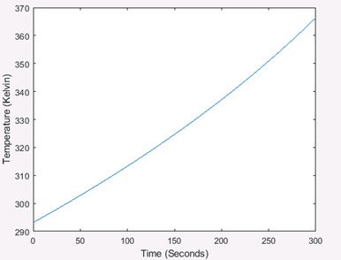

**Figure 1.** Matlab result to the ordinary differential equation of a flat plane in space. Function ODE45 was used to solve the equation. After 5 minutes of being exposed to the sun the plane reaches a final temperature of 366.4 K

Once the ODE was solved using Matlab, the ANSYS model was built to verify the results. The results of the ANSYS model can be seen in figure 2. The ANSYS results yielded a final temperature of 372.4 kelvin. This ended up being close to the Matlab value of 366.4 kelvin but upon further inspection of figure 1 and figure 2 it can be seen that one graph is exponential while the other is logarithmic. Currently we are looking into why there is this discrepancy. We believe the error is in the matlab code as the graph should be logarithmic since the plane should eventually reach a steady state value. For the heat distribution on the plane see Figure A.1.

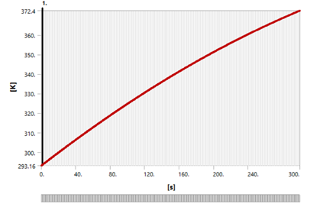

**Figure 2.** ANSYS results the temperature rise of a flat plane facing the sun during the first 5 minutes in space starting with an initial temperature 293.15 K. For this simulation the max temperature is 372.4 K

After the single plane model, the hollow cube simulation was set up to have one side facing the sun with a heat flux of 1356 W/m2 and one side facing the Earth with a heat flux of 350 W/m2, with the rest of the cube radiating to deep space. ANSYS results for the hollow cube simulation can be seen in Figure 3. Here the cubesat reached a final max temperature of 299.32 Kelvin. For the results over time see figure A.2. and A.3 in the appendix.

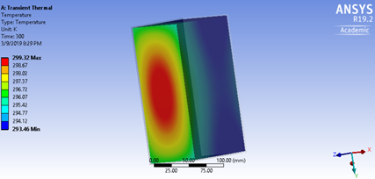

**Figure 3.** Ansys results of temperature distribution of a hollow cube in space with an internal heat generation of 3 watts and emissivity values of 1. After 5 minutes the cube reached a max surface temperature of 299.32 K on the sun facing side.

## Conclusion and Recommendations

Over the past term the capstone team has made significant progress in understanding OreSat’s thermal states, and the project is on track with the preplanned timeline. The team has completed a one dimensional lumped capacitance heat transfer simulation, verified findings with analytical hand calculations, and started undertaking a three dimensional transient heat transfer simulation. Concurrently, they are validating and refining the one dimension mathematical model of the thermal system in an effort to reduce error. By improving the one dimensional model, we can tune the boundary conditions of our three dimensional simulations. The majority of the first two terms of the project were spent learning software, gathering information, creating math models, and running simple simulations. The most complex aspects of the project lie ahead.

Currently our project is progressing on schedule to meet the customer’s needs even though simulation analysis has taken longer than expected. As the model gets more complex, assumptions will need to be made to simplify the model to expedite calculations. This is something that our customer is slightly adverse to, however with explanations clearly stating the logic of our assumptions, and accurate validation the thermal analysis will still be accurate.

Next term the team will be very busy refining the current three dimensional model to represent the satellite accurately. After an accurate shell model is created, internal components will be added to the main simulation. The next major milestone to achieve will be getting the final refined simulation validated through vacuum chamber testing. After that the final step is to create recommended design modifications for the OreSat team.

## 

## References

[1] Chandrashekar, S., 2016, “Thermal Analysis and Control of MIST CubeSat,” Master Thesis, KTH Royal Institute in Technology, Stockholm, Sweden.

[2] Dinh, D., 2012, “Thermal Modeling of Nanosat,” Master Thesis, San Jose State University, San Jose, CA.

## Appendix A

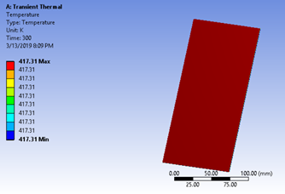

**Figure A.1.** ANSYS result of the temperature distribution of a flat plane facing the sun after 5 minutes. In this case the plane is uniformly heated due to it all being exposed directly to the sun.

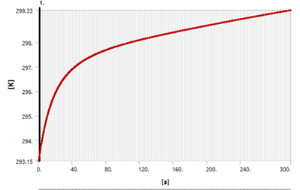

**Figure A.2.** ANSYS results of a hollow cube in space with one side facing the sun and, the opposite side facing Earth and the other sides radiating to space. During the first 5 minutes in space the cube temperature rose by 6.18 degrees kelvin.

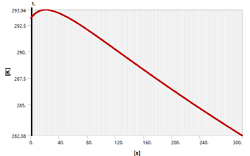

**Figure A3.** ANSYS results of a hollow cube in space with one side facing the Earth and the other sides radiating to space. During the first 5 minutes in space the cube temperature drops by 11.07 degrees kelvin.

## 

## Appendix B

### Matlab Script for Radiation Through a Plane

function dTdt = odefunRad_case1(t,T)  
  
% Symbolic Notation  
%syms T(t)   
% T is Temperature; t is time.   
  
% Satellite Properties  
% One Plate  
plate_height = 0.2; % Units: m  
plate_width = 0.1; % Units: m  
plate_thickness = 0.001704; % Units: m  
  
% Aluminum Properties  
cp = 921.096; % Units: J/(kg*K)  
rho = 2.7*10^3; % Units: kg/m^3  
m = 2.33/5; % Units: kg  
  
% System Properties  
boltz = 5.67*10^-8; % Units: W/(m^2-K^4)   
F = 1; % View Factor  
epsilon = 1; %   
  
% Heat Flux terms  
q_solar = 1400; % W/m^2  
q_earth = 350; % W/m^2  
q_internal = 3; % W/m^2   
 % Q_internal has an assumed flux value for now.  
  
% Temperature terms  
T_OreSat = 293.15; % Units: K  
 % T_OreSat is assumed to be room temperature.  
T_DeepSpace = 2.7; % Units: K  
  
%dTdt = zeros(1,1)  
dTdt = (((q_solar/(m*cp)) + (q_earth/(m*cp)))*plate_height*plate_width)+(q_internal/(m*cp)) + (boltz/(rho*plate_thickness*cp))*((T^4)-(T_DeepSpace^4));  
End